GAME OF CRAPS

CODE:

// craps.cpp : This file contains the 'main' function. Program execution begins and ends there.

//

#include "pch.h"

#include <iostream>

#include<ctime>//for running srand fn

using namespace std;

void DisplayStatus(int, int);//to display the status

void PlayGame(int&, int&);//set playgame to iteger values

int RollDice();

int main()//main program

{

int menuChoice, wins=0, losses=0;

srand((unsigned)time(0));//for random integers

do {

cout << "To play a game of craps,enter1" << endl;

cout << "To view player status,enter2" << endl;

cout << "To exit the program,enter3" << endl;

cin >> menuChoice;

if (!cin)

cin.clear();

cin.ignore(100, '\n');

cout << "\nplease enter the valid integer" << endl << endl;

cin.ignore(100, '\n');

cout << "\nplease enter the valid integer" << endl << endl;

switch (menuChoice)//swich fn forplaygame and displaystutus

{

case 1:

PlayGame(wins, losses);

break;

case 2:

DisplayStatus(wins, losses);

break;

case 3:

break;

default:

cout << "\ninvalid input" << endl << endl;

}

} while (menuChoice!= 3);//while loop for three func.

return 0;

}

void DisplayStatus(int wins, int losses)//to display whether win or loss

{

cout << "\nWins: " << wins << endl;

cout << "Losses: " << losses << endl << endl;

}

void PlayGame(int& wins, int& losses)

{

int FirstRoll = 0, roll = 0, point = 0;

bool isWon = false;//bool for set the two conditions true or false

FirstRoll = RollDice();//set values from rolldice() to first roll

if (FirstRoll == 7 || FirstRoll == 11)//if condition for win situation

{

cout << "player wins" << endl;

wins++;

}

else if (FirstRoll == 2 || FirstRoll == 3 || FirstRoll == 12)//else if for loss condition

{

cout << "player losses" << endl;

losses++;

}

else if (FirstRoll == 4 || FirstRoll == 5 || FirstRoll == 6 || FirstRoll == 8 || FirstRoll == 9 || FirstRoll == 10)//for rest of values

{point = FirstRoll;//assign value of first roll to point

cout << "points are:" << endl << "roll dice 2nd time" << point << endl;

int die3 = rand() % 6 + 1;//random values untill7

int die4 = rand() % 6 + 1;

int sum1 = die3 + die4;//add die3 and die4

cout << "2nd chance" << sum1;

if (sum1 == 7)

{

cout << "loss";

}

else if (FirstRoll == sum1)//else if condition when first roll equals to sum1

{

cout << "congo";

}}

while (isWon = false)//while loop when iswon is false

{

roll = RollDice();

if (roll == point)

{

cout << "player wins" << endl;

wins++;

isWon = true;

}

else if (roll == 7)//when dice sum 7 for first time

{

cout << "player losses:" << endl;

losses++;

isWon = true;

}

}

}

int RollDice()//roll dice defination

{ int die1 = rand() % 6 + 1;

int die2 = rand() % 6 + 1;

int sum = die1 + die2;

cout << "player rolled" << die1 << ", " << die2 << "= " << sum << endl;

return sum;

}

// Run program: Ctrl + F5 or Debug > Start Without Debugging menu

// Debug program: F5 or Debug > Start Debugging menu

// Tips for Getting Started:

// 1. Use the Solution Explorer window to add/manage files

// 2. Use the Team Explorer window to connect to source control

// 3. Use the Output window to see build output and other messages

// 4. Use the Error List window to view errors

// 5. Go to Project > Add New Item to create new code files, or Project > Add Existing Item to add existing code files to the project

// 6. In the future, to open this project again, go to File > Open > Project and select the .sln file

OUTPUTS

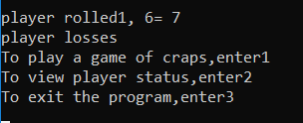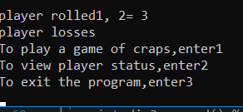

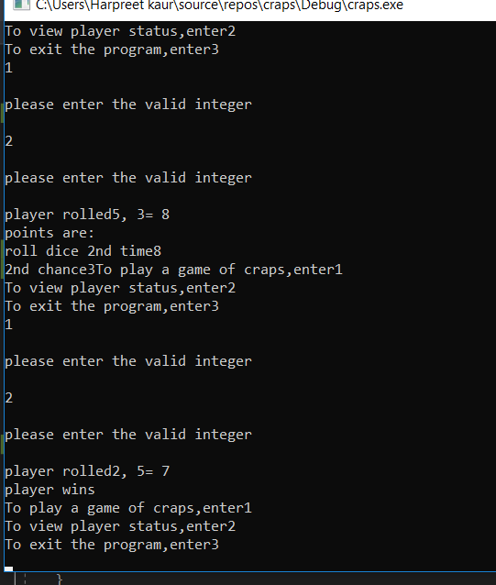

SUBMITTED BY -Harpreet Kaur (742133)

Manpreet Kaur (730931)

UML Activity diagram

